**Lights and Textures Project**

Benjamin P. Marquis

University of Maryland Global Campus, Department of Computer Science

CMSC 405: Computer Graphics Section 6381

Dr. Cynthia Marcello

March 8, 2022

1. **Overview**

This project builds off of the previously completed project. The previously completed project included 6 objects in 3-dimensional space. A yellow cube, a blue cylinder, an orange torus, a red ball, a green torus knot, and a green dodecahedron. Each item has a different slider that corresponds to it, each slider has a different effect on its respective object. There are three lights in the image, a red light positioned to the left, a white light that is slightly to the right and back, and an ambient soft white light.

4 more objects have been added below the original 6 objects. One is a rectangular prism with a brick texture. Another is a metal box. Another is a representation of the earth as a globe. And the final object is a marble.

The 4 lower objects are made with MeshBasicMaterial over which the image files representing their appearance were laid. The front 3 upper objects use the MeshPhongMaterial which demonstrates the appear of the lights very well. The rear 3 upper objects are made with MeshLambertMaterial.

1. **Execution**

Start:

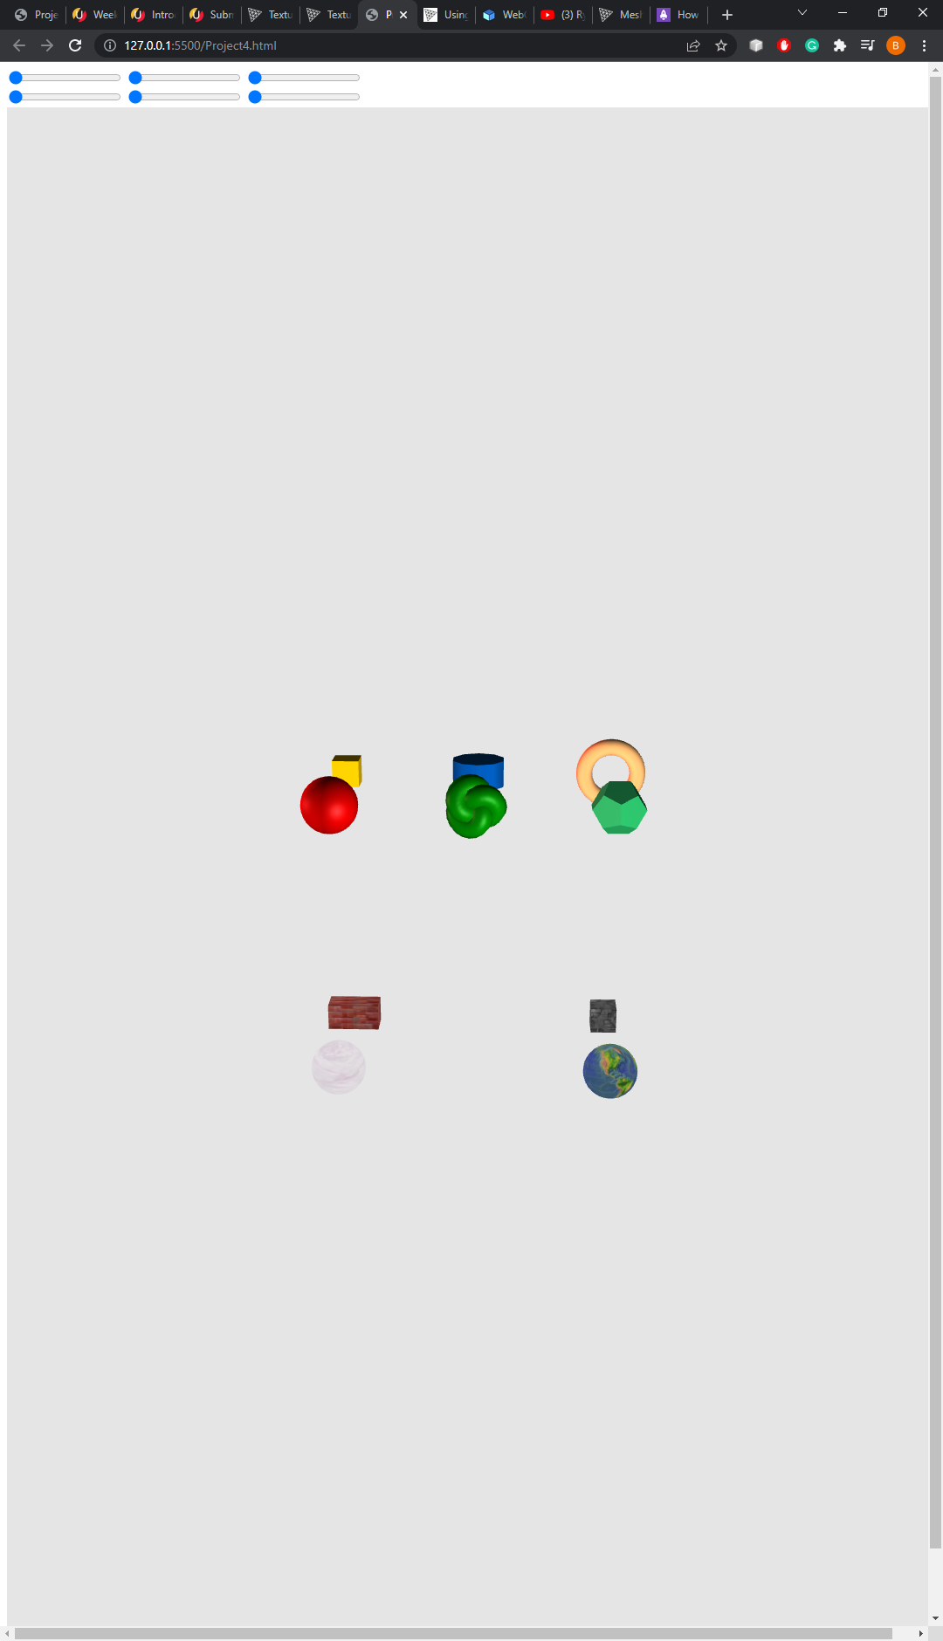

This is the starting position

Sliders set to middle value:

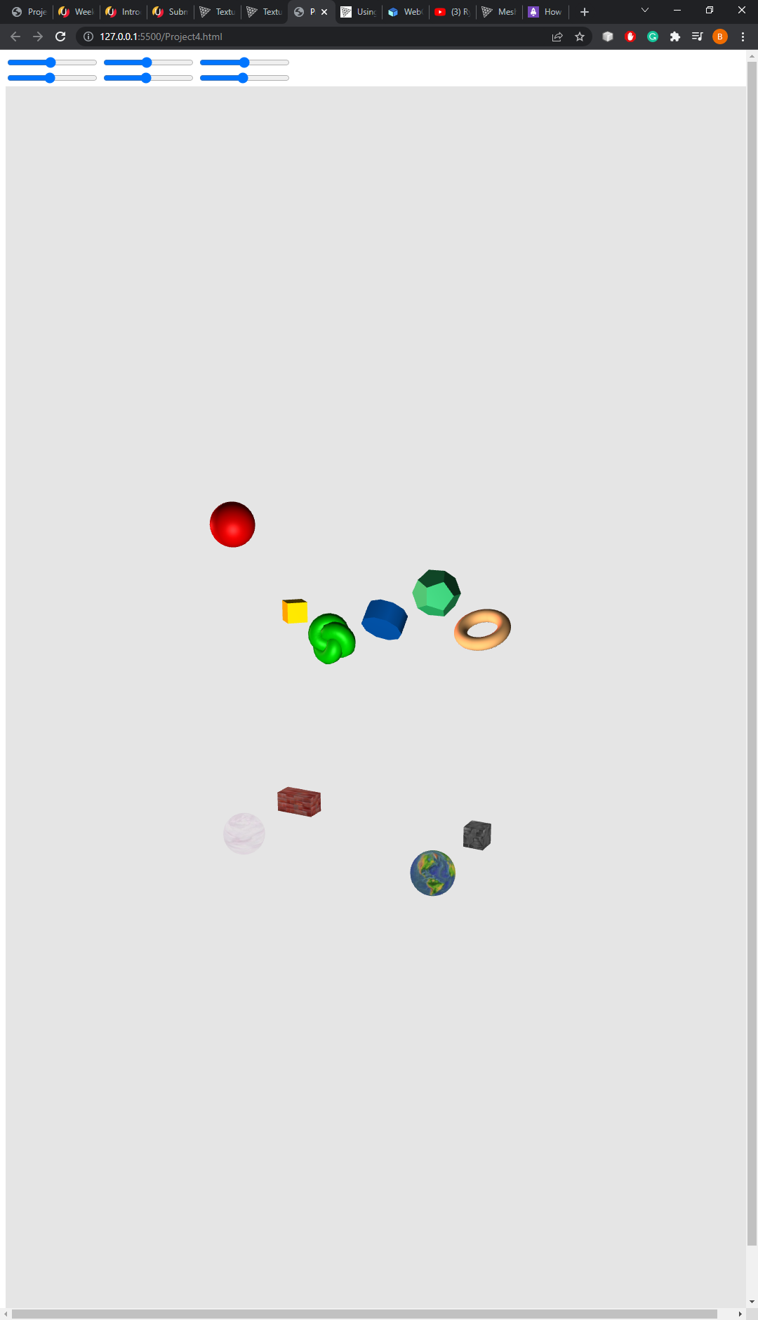

Sliders set to full value:

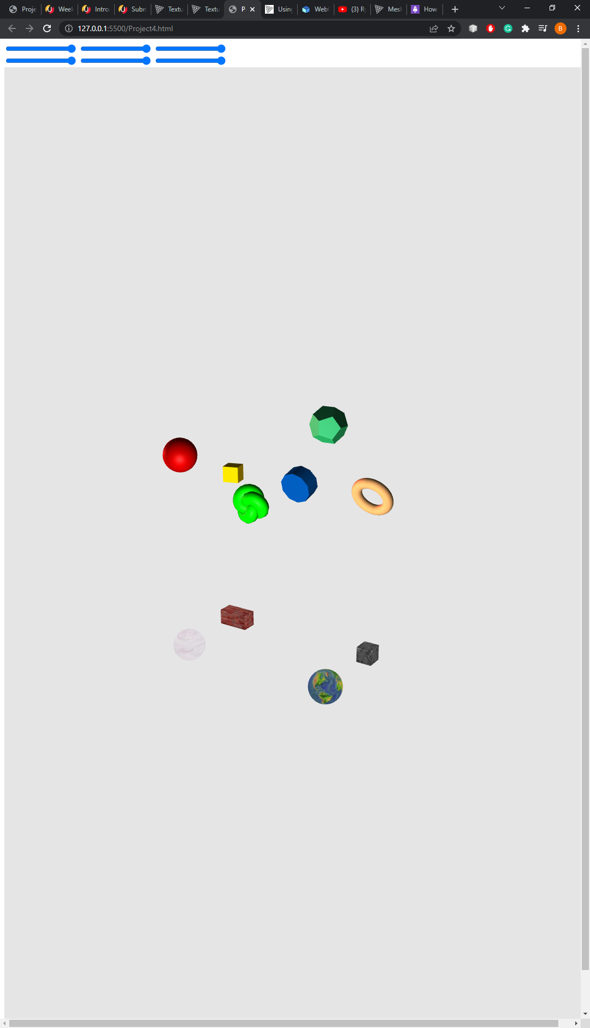

1. **Testing**

The testing involved first ensuring that each object was populated properly on the screen.

Then it was verified that each light effect was properly visible as intended. Each slider bar was then tested for proper effect on the correlated object. Each test passed in succession and the file is performing as normal.

|  |  |  |  |  |
| --- | --- | --- | --- | --- |
| **Test Case** | **Input** | **Expected Output** | **Actual Output** | **Result** |
| Yellow Cube | N/A | Visible | Visible | Pass |
| Blue Cylinder | N/A | Visible | Visible | Pass |
| Orange Ring | N/A | Visible | Visible | Pass |
| Red Ball | N/A | Visible | Visible | Pass |
| Green Torus Knot | N/A | Visible | Visible | Pass |
| Green Dodecahedron | N/A | Visible | Visible | Pass |
| Brick Prism | N/A | Visible | Visible | Pass |
| Metal Box | N/A | Visible | Visible | Pass |
| Globe | N/A | Visible | Visible | Pass |
| Marble | N/A | Visible | Visible | Pass |
| Ambient light | N/A | Ambient light visible | Ambient light visible | Pass |
| Point light white | N/A | White front faces of objects | White front faces of objects | Pass |
| Point light soft red | N/A | Red shade on left side of objects | Red shade on left side of objects | Pass |
| Stretch | 2.0 x .5 y | image stretch | image stretch | Pass |
| Slider 1 | Slide right | Yellow cube rotates around y axis | Yellow cube rotates around y axis | Pass |
| Slider 2 | Slide right | Blue cylinder rotates around x axis | Blue cylinder rotates around x axis | Pass |
| Slider 3 | Slide right | Orange torus accelerates automatic spin around x axis | Orange torus accelerates automatic spin around x axis | Pass |
| Slider 4 | Slide right | Red ball bounces at greater and greater magnitude | Red ball bounces at greater and greater magnitude | Pass |
| Slider 5 | Slide right | Green torus knot changes depth of green | Green torus knot changes depth of green | Pass |
| Slider 6 | Slide right | Green dodecahedron slides up y axis | Green dodecahedron slides up y axis | Pass |